**Applied Bayesian Statistics**

**Practice on the likelihood function, prior, and posterior distribution under different priors**

|  |  |
| --- | --- |
| Assume you are the assistant coach of the women’s softball team at VT. The head coach has asked you to assess a new first year player who is joining the team. As a high school student, she was at bat 120 times and got 40 hits. You wish to estimate $π$, her underlying true probability of getting a hit in any at bat as a college-level player. |  |

* The first step in Bayesian framework is specifying a prior distribution for the parameter, population proportion, that seems appropriate to capture your knowledge or uncertainty about θ before the new player plays in any college-level games. Here are some possible priors.

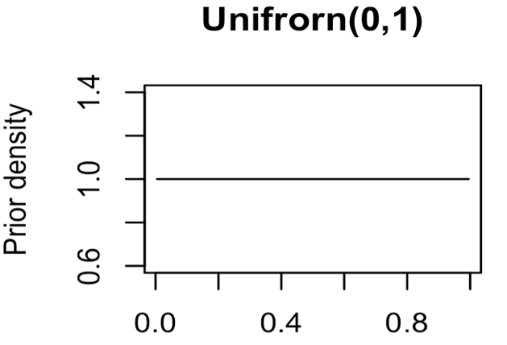 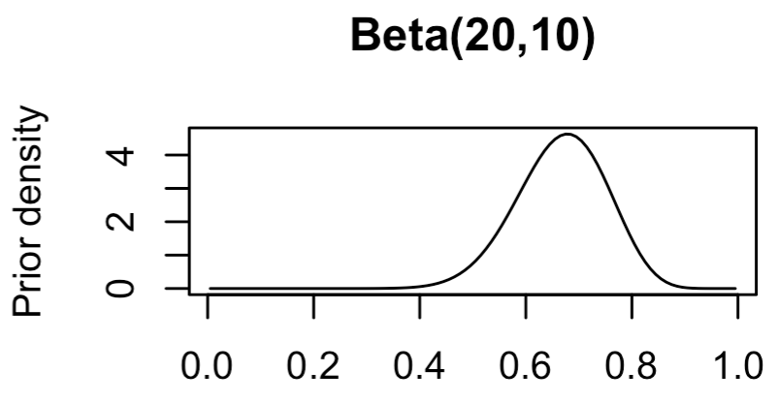

A uniform (noninformative) prior. The mother’s prior.

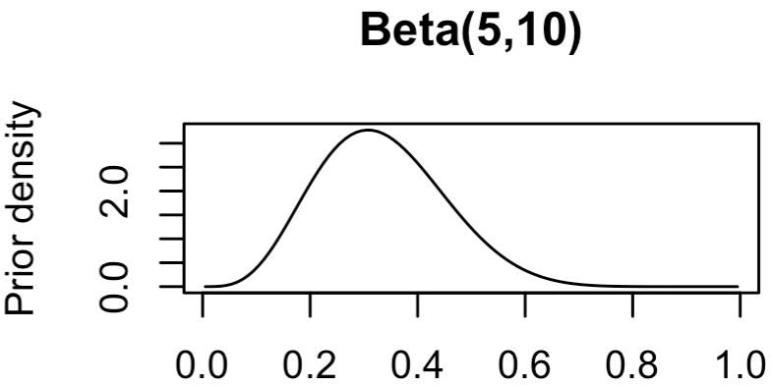 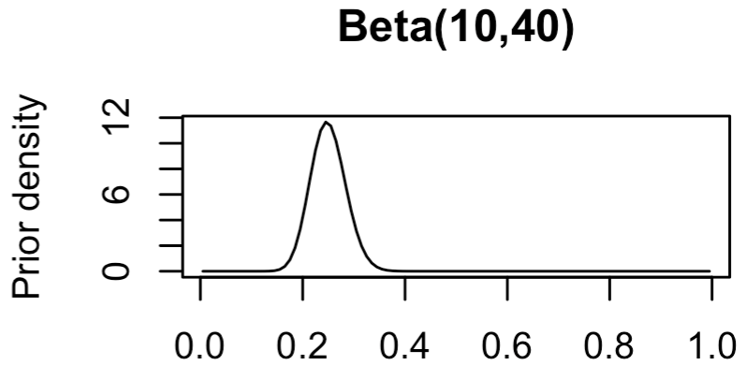

* Which prior matches your beliefs about $π$? And why?
* The second step is to specify the likelihood function. Suppose the player now plays eight college-level games, has thirty at bats, and gets 5 hits. Thus, the data are y=5, n=30. Write down the likelihood function.
* Obtain the posterior distribution p( |y) under each of the above priors.
* Complete the following table:

|  |  |  |  |
| --- | --- | --- | --- |
| Prior distribution | Posterior distribution with its parameters | Posterior Mean | Standard deviation |
| Uniform  Mothers prior  Beta(5, 10)  Beta(10, 40) |  |  |  |

* What is the frequentist approach estimation for $π$?